vROps Odyssey Validation – Manual Steps

# Task 1 – Capacity Reclamation

From the Home (Quick Start) page, Optimize Capacity tile, click Reclaim

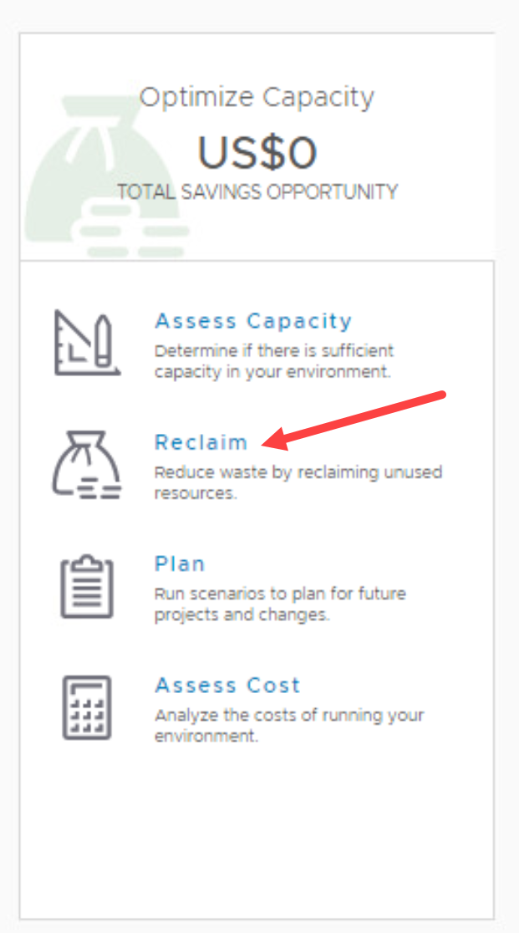

Click the Regional Datacenter tile

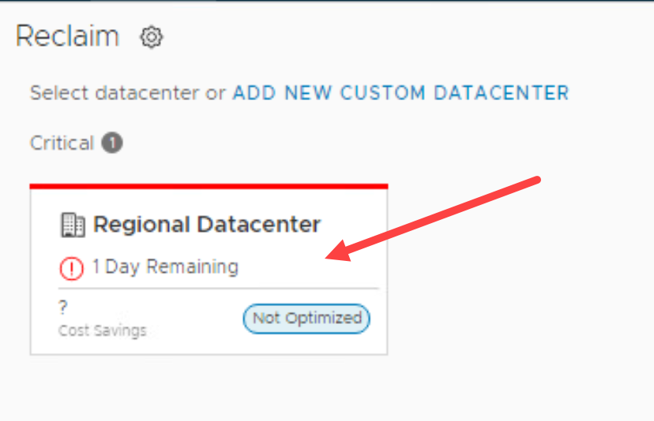

At the bottom, click “Snapshots”.

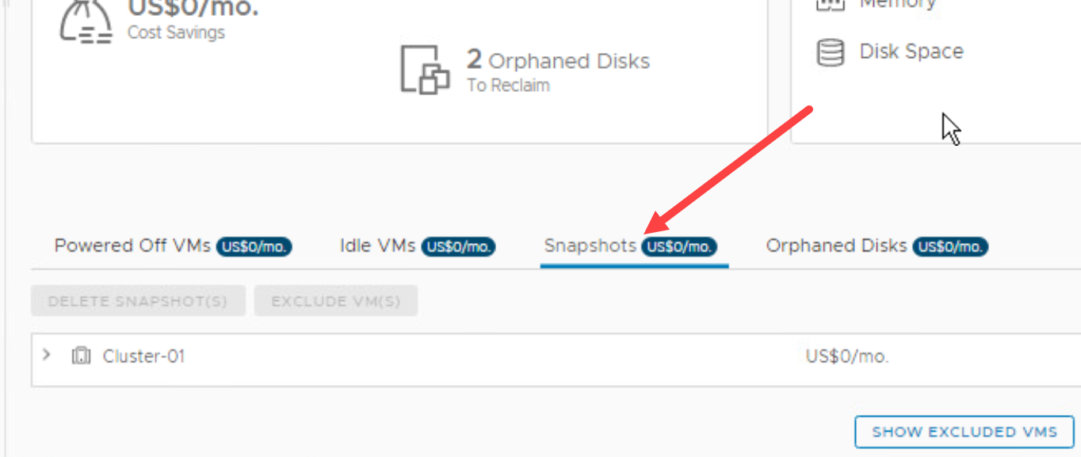

Verify:

**You should NOT see Cluster-02 here**. Note that you may see Cluster-01.

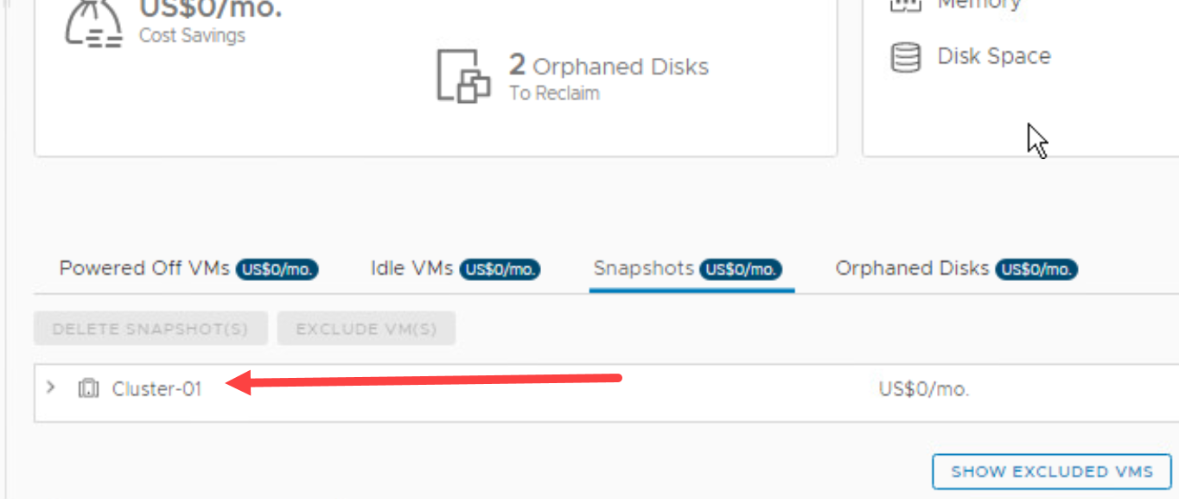

# Task 1 – Alert Creation

1. In the main navigation bar, click Alerts
2. On the left, expand Alert Settings
3. Click Alert Definitions
4. In the All Filters box, type ody and press Enter

Verify all fields enclosed in the red boxes.

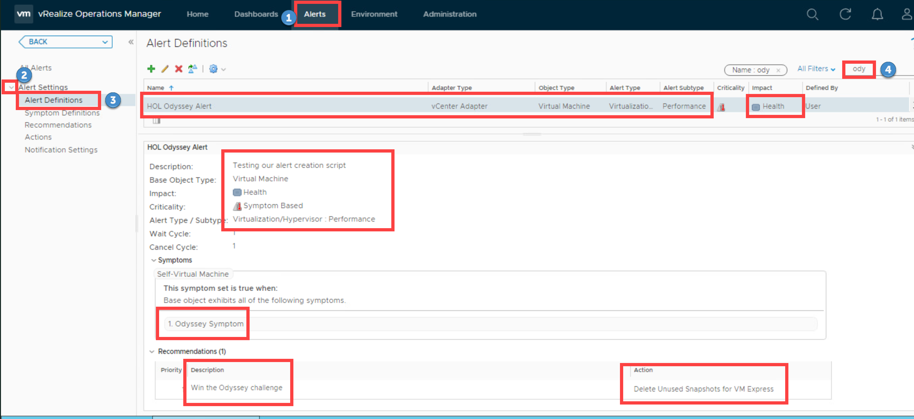

# 3. Super Metric Creation

Click the magnifying glass on the right side of the main navigation bar at the top

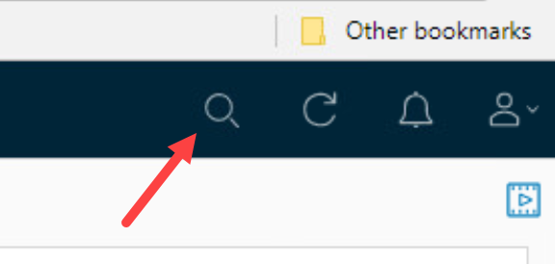

In the search box, type Cluster. Click Cluster-02 in the drop-down list

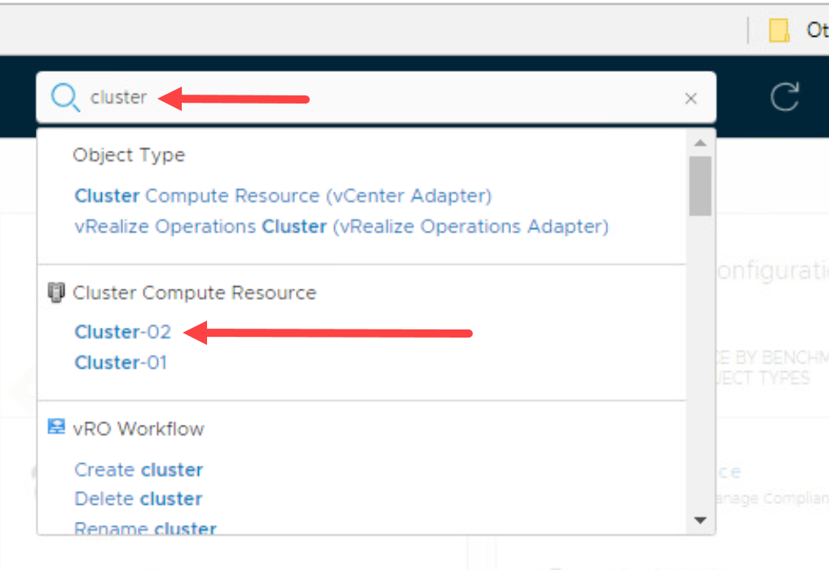

(top to bottom arrows in screen shot)

Click All Metrics

Expand the All Metrics heading

Expand the Super Metric category **if you do not see this category, wait 120 seconds and refresh. If you still do not see it, validation fails

Double-click “Cluster VM Avg CPU (%)” **If you do not see this metric, then validation fails

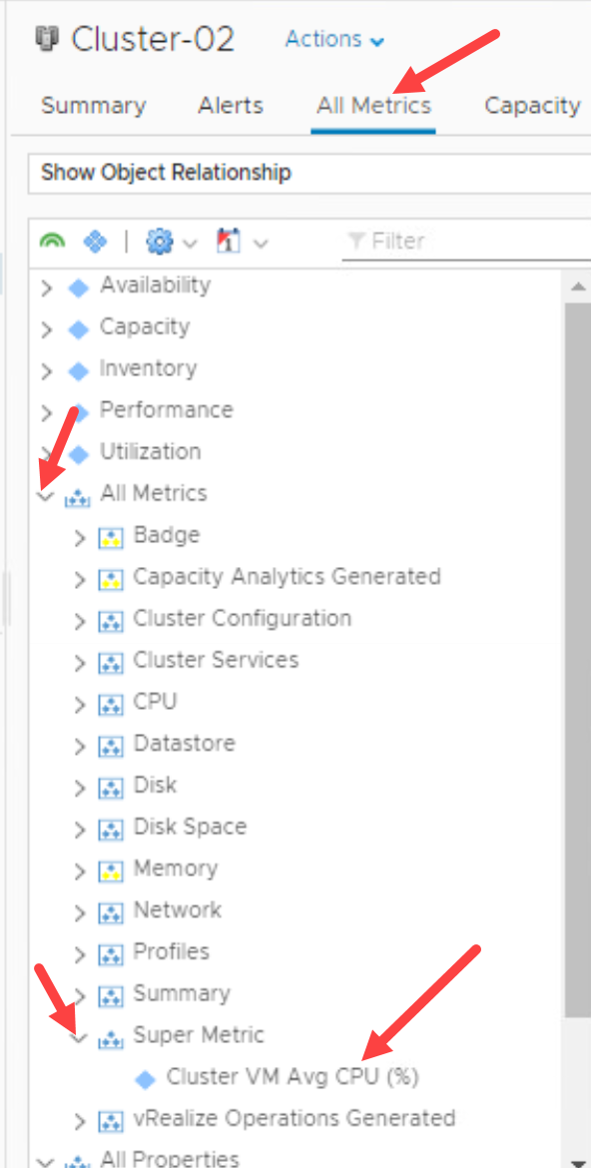

After you double-click the super metric name, you should see a graph to the right.

Validation: The numeric high and low values (H:, L:) are not zero

